https://www.youtube.com/watch?v=gb0bytUGDnQ

Step 1) <https://cloud.google.com>

Step 2) Get strated For Free Trial

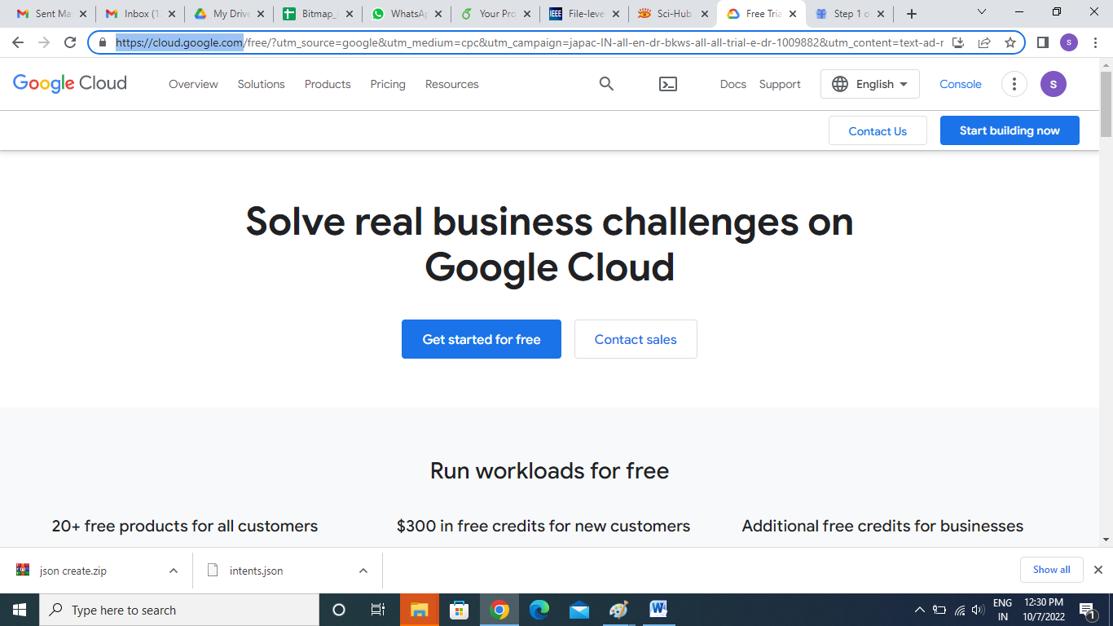

Step 3) add Account Information

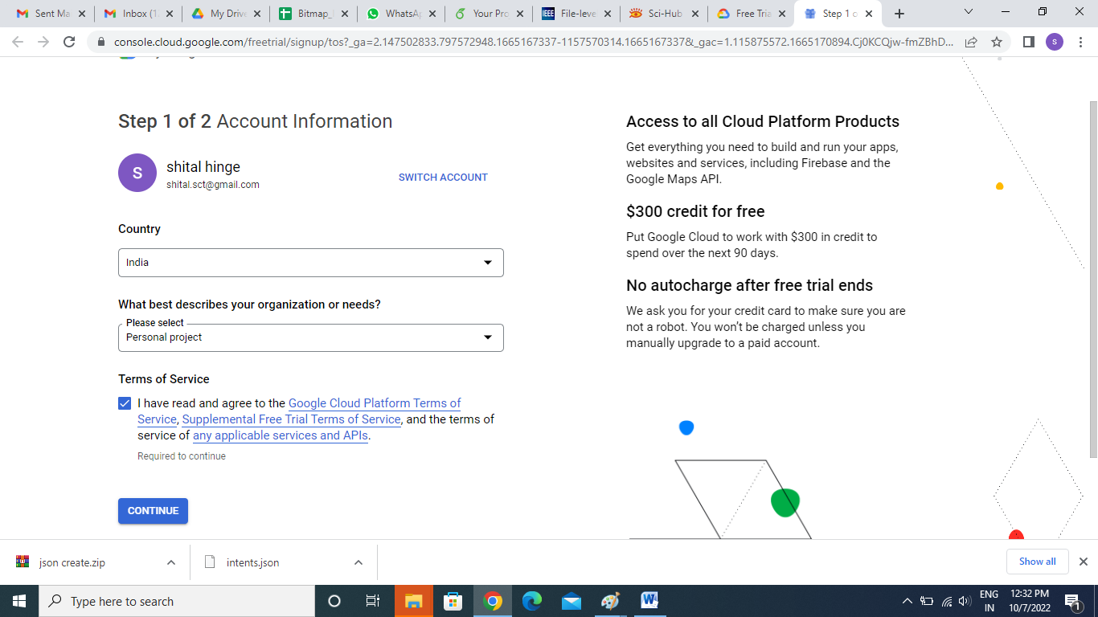

## Step 4) Payment Information Verification

## Enter Business Name:-Individual

## Enter Card No

## Enter card holder details

## Click on -Start my Free Trial

## 

## Step 5: enter Last 3 No of master card or Visa Card

## 

## Step 6:

## Enter Otp (OTP will Be Receive Register Mobile No) and Do Payment process

## 

## Step 7- Then go to home page which is the dashboard You want to click on navigation-> Then Next Go IAM And Admin

## 

## Steps 8:- -> then go to service Account->create service Account

## 

## Select Role:-owner

## 

## key Not Assign

## 

## Step 9: Assigned Key🡪 manage key->Add Key

## 

## Step 10:- Create New Key:-

## C:\Users\TEMP\AppData\Local\Microsoft\Windows\INetCache\Content.Word\13.png

## Steps 10: Json Download and save Your Folder Automaticaly or may be some time itself

## Step 11:- close

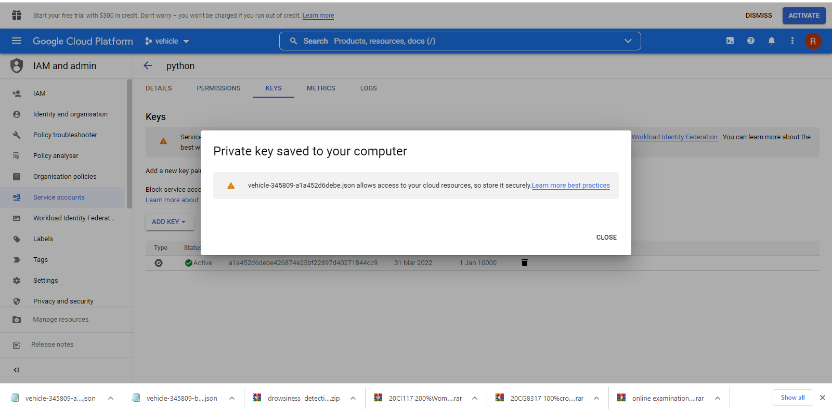

Create Your New Project

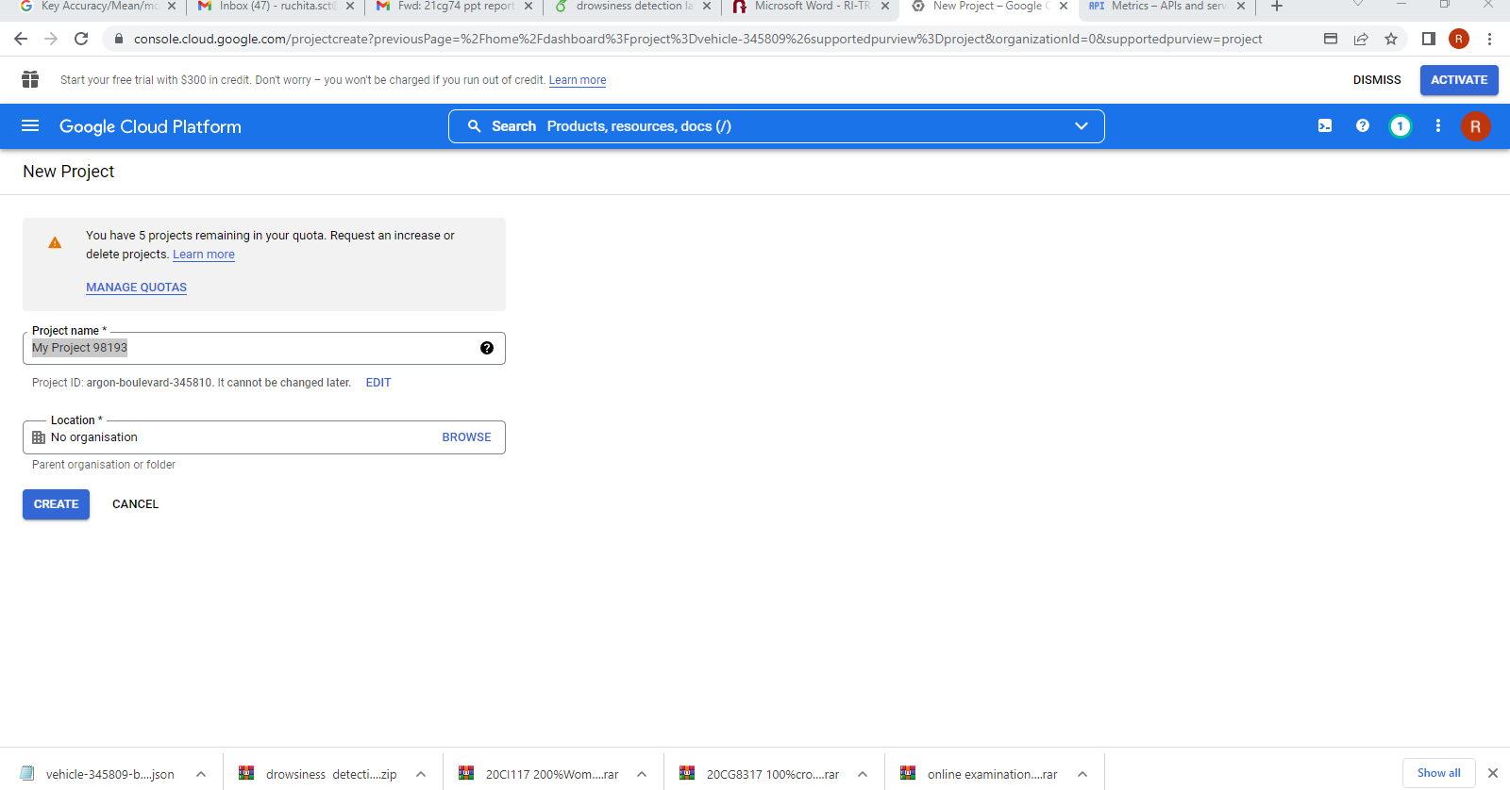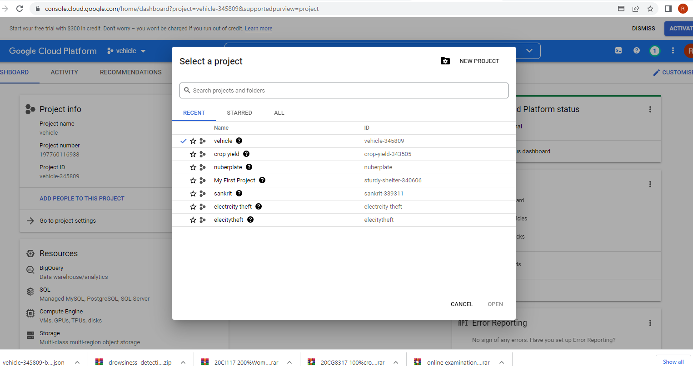

Steps 12:- Add Your Json to Project Folder Copy json Path and Pest Project code and run your . py File-> After Some Error Genrate at console.

Steps 13:- then Copy console error link link- Url Link and pest on google and Enable Google api

